INTERNAL MOCK EXAMINATIONS – 2018
Uganda Advanced Certificate of Education
BIOLOGY P530/3
MARKING GUIDE
1. (a) (i)
Male;
  - Black coloured nuptial pad of the first and second fingers.
  - Light coloured under the throat, if male
  - Under side of throat is dark coloured
  - Body is broad.

(ii) Tympanic membrane, / ear drum/ tympanum/ ear circular shaped/
disc- shaped ,/ flattened,/ membranous, tightly stretched,
Dorso- laterally positioned posterior to each eye,
Each of the two eyes has large eye ball, plptrude out, slightly
movable upper eyelid, lower transparent nictating membrane.
Lie dorsally, but face laterally to each other and mid –dorsal lie of
the head,
Nostrils/ external hares,
Paired, oval- shaped openings small in size,
Each posteriorly positioned close to the shout, immediately above
the mouth.

(b) (i) Sticky, for grasping pre hence reducing escape chances of prey,
- Flattened to increase surface area for capturing/ traping prey.
- Long and elastic/ for catching prey at far distance.
- Attached auteriourly, to be flicked quickly to prey at a relatively
longer distance.

(Any 3x 1=0 3 marks)

(ii) DRAWING OF THE STRUCTURES OF THE BUCCAL CAVITY
AND PHARYNX AFTER DISPLACING THE LOWER JAW TO THE
RIGHT

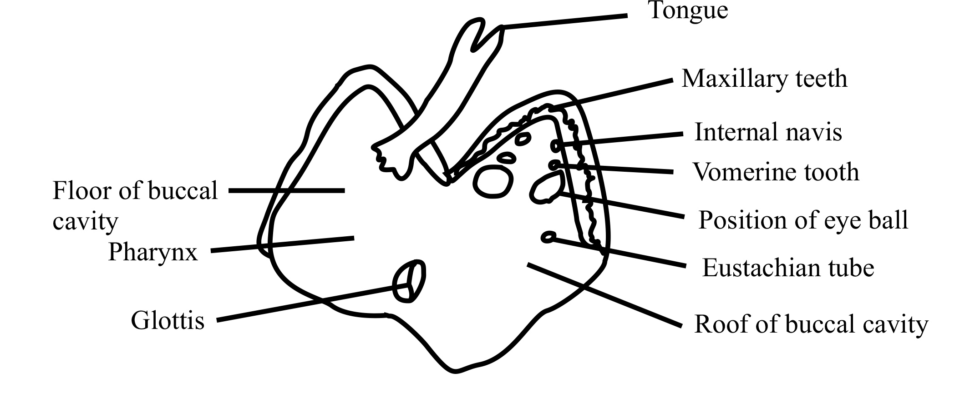

- DRAWING OF STRUCTURES LINING THE REGION BETWEEN THE FORE AND HIND LIMBS, EXCLUDING THE STRUCTURES USED FOR REPRODUCTION WITH INTESTINES DISPLACED TO THE LEFT OF SPECIMEN P.
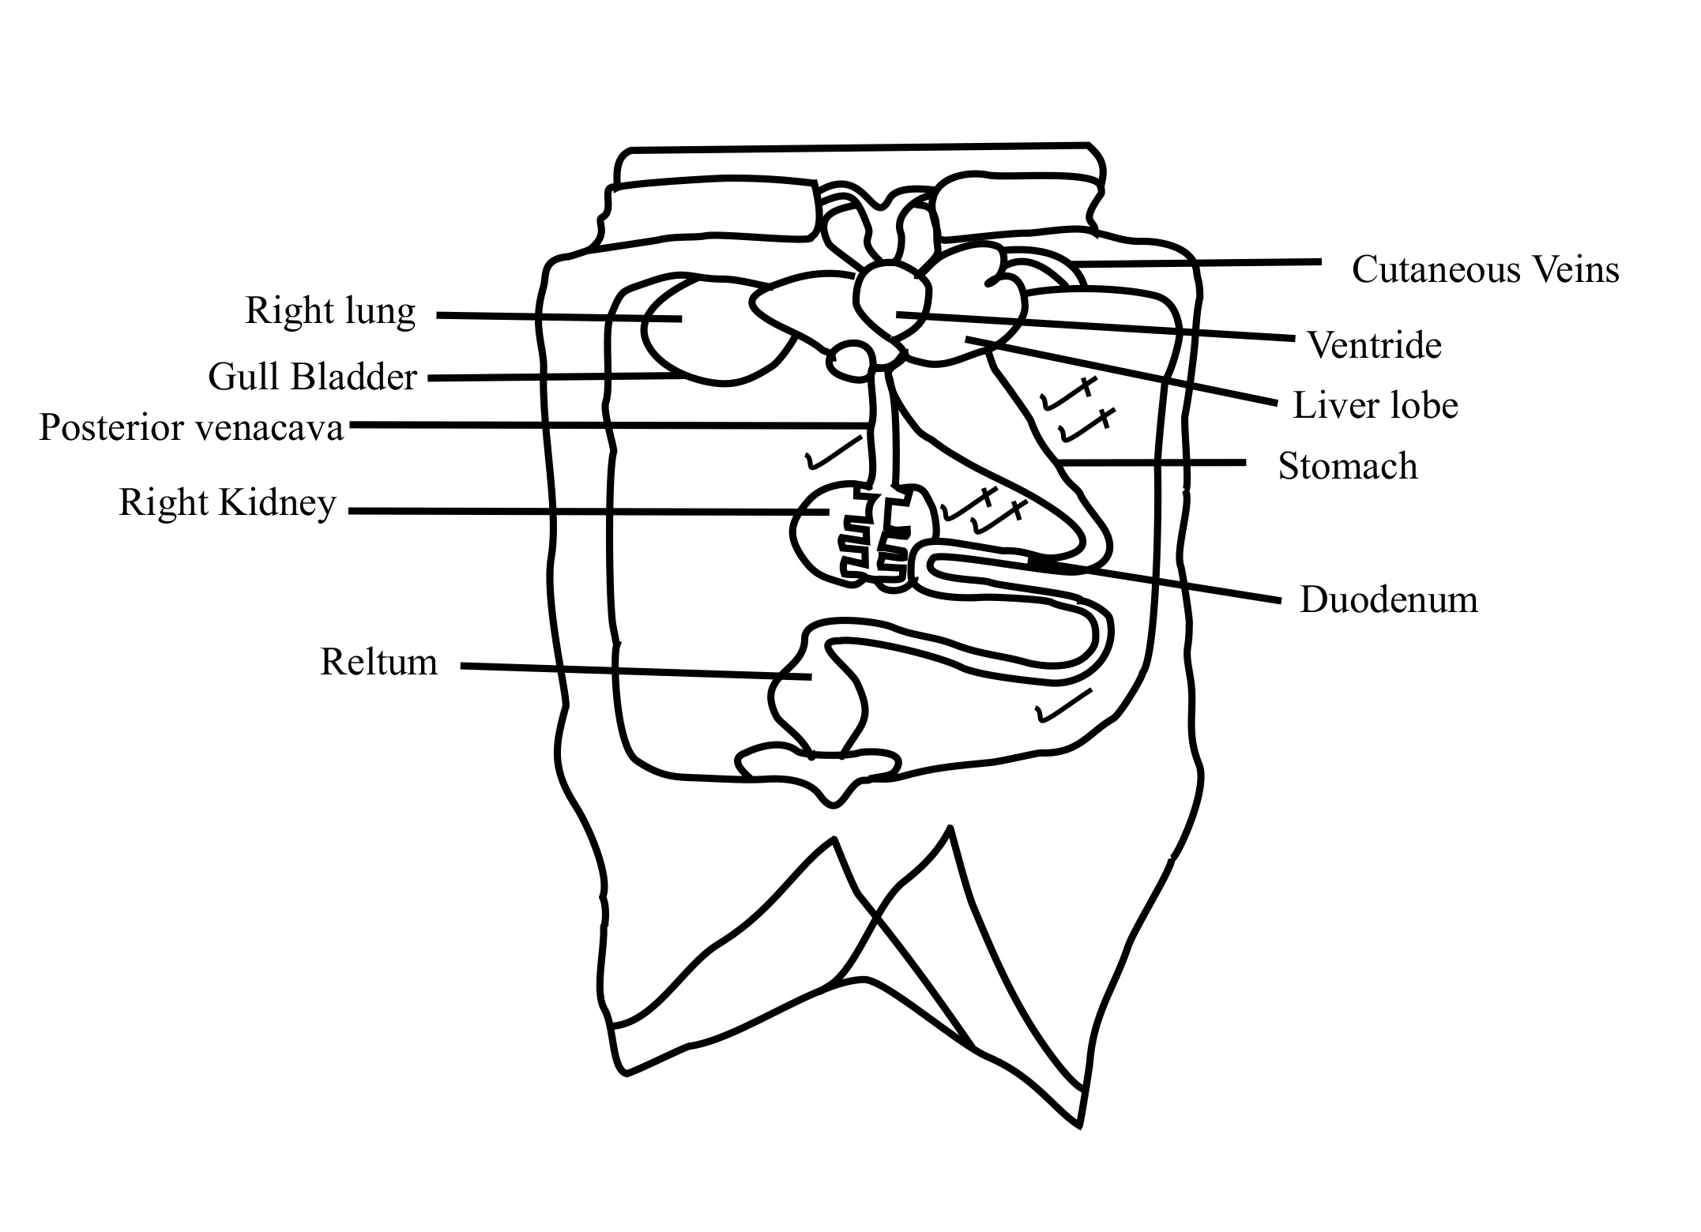
T - 01
O - 01
D/L – 14
M – 01
AD – 01
DS – 01
VD – 01
= 20
X ½ - X2
2.
Table 1
Tests | Observations | Deductions
Lodine test  To 1cm3 of solution A, was added 2/3 drops of iodine solute. | Turbid solutions, turned to a black solution | Much starch presents
Benedict’s test  To 1 cm3 of solution A, was added 1cm3 of Benedicts’ solution, and boiled, | Turbid solution, turned to a pale blue solution, which turned into a green solution acc persisted | Traces / little reducing sugars present
Buirect’s test  To 1cm3 of solution A, was added 1cm3, of sodium hydroxide solution, followed by ¾, drops of copper (ii) sulphate solution; | Turbid solution, turned to a pale purple solution, | Littled traces protein present

Rej- wright observation, deduction if procedure is wrong.
Acc ratio of 1:1 for Benedict’s test.

Table 3
Test tube
1 | Turbid mixture completely clears | Solution A hydrolyzed completely
2 | Turbid solution partially clears | Solution A was partially hydrolyzed
3 | Turbid solution remains turbidly | No hydrolysis of A
(06 marks)
Table5

Test tube
4 | Many bubbles/ fast effervescence | Rapid decomposition of solution P.
5 | Moderate bubbles.  Moderate effervescence | Moderate decomposition of solution P
6 | Fewer bubbles/ slow effervescence | Slow decomposition of solution P,
(06 marks)

- (i) During germination enzymes are activated, which catalyze the hydrolysis
of complex food substances in A, giving a clear solution, the more the
days of growths, the greater is the clearity of the solution A, solution B
has both protease, and amylase, so there is complete hydrolysis of
solution, so there is partial hydrolysis of solution A, but no hydrolysis of
A, by solution D because few or no enzyme molecules have been
activated; (05 marks)

(ii) Table 5
Growth is associated with increase in metabolism, and hence release of metabolic wastes such as H₂O₂, catalyze is secreted, to catalyze the break down of H₂O₂,
The more the days of germination/ growth, the greater is its metabolic wastes, and the higher the concentration of catalyze, which rapidly decomposed P, (05 marks)

(iii) Break down of toxic wastes (01 mark)
(iv) To allow enzymes in solution to separate out since they are soluble

3. (a) Has a main axis with lateral branches of variable length,reducing
towards the apex, on each lateral branch of the axes are numerous spikes bearing several spikelet’s, each spikelet is enclosed by 3 hardened, smooth, boat- shaped and pointed bracts, one placed a little below the two;

(b) DRAWING OF A FLORET OF SPECIMEN R.

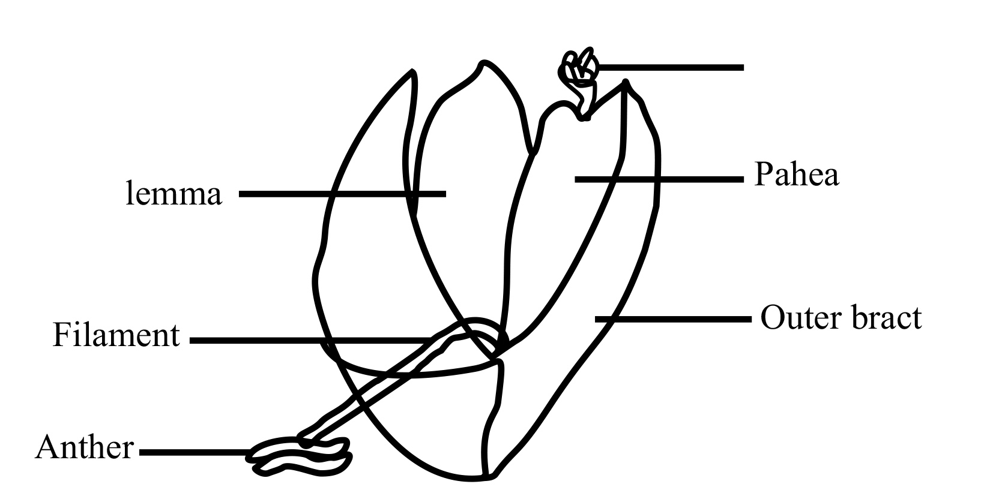
(c)

Floret of T | Floret of R
1.Has sepals  2. has petals  3. Has one stigma  4. Petals/ corolla are fused  5. Regular / actinomorphur  6. stigma not feathery  7. Corolla brightly coloured | No sepals  No petals,  Has 2 stigmas,  Bracts are free,  Irreguear/ zygomorphic  Has feathery stigmas  Bracts dull coloured

(d) (i) Anthers are brood, for production of much pollen, to increase
chances of wind pollination.
  - Filaments are long, for /to easily be blown by wind in different directions,
  - Stigmas are feathery, to filter pollen from air/ for high chances of pollination.
  - Florets are cronoded, to produce much pollen to increase chances of wind pollination,
  - Are dull colored for effective camouflage from predators, hence survive and produce pollen.

(ii) Corolla of T is brightly coloured, to attract insect pollinators, while bracts
of R are dull coloured.
Stamens and pistils of T are enclosed in the corolla tube, preventing mechanical damage but the anthers of R hang out and exposed to danger

(e) DRAWING OF OUTER FLORET OF SPECIMEN S.

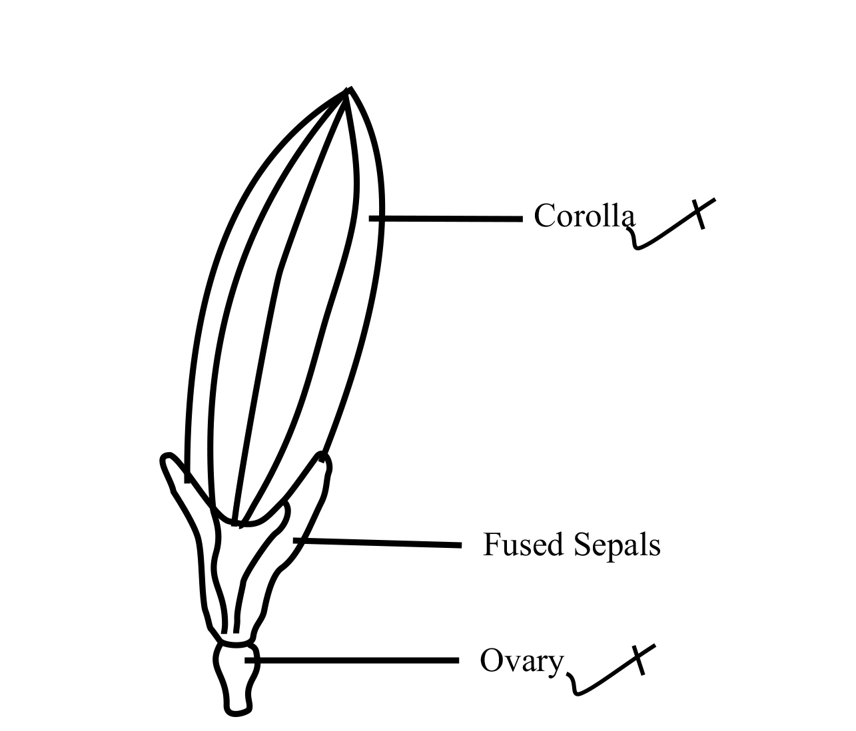

X 15 – X25
Magnification should be in the range and realistic.

END

